**User Service Endpoints**  
**Getting all users**  
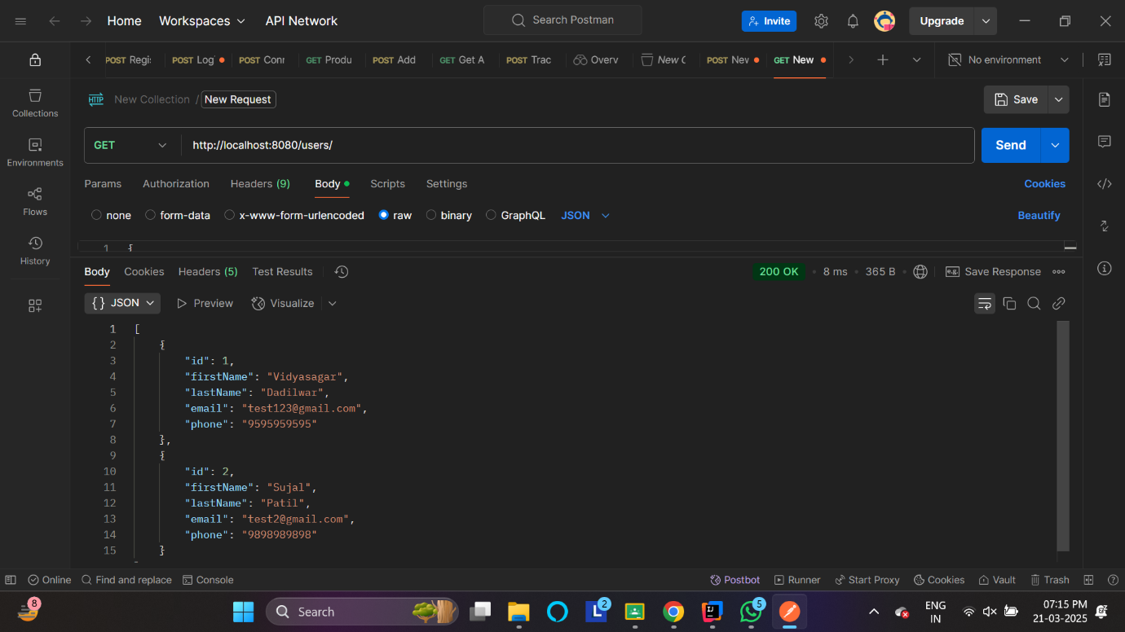  
  
**Getting a specific user**  
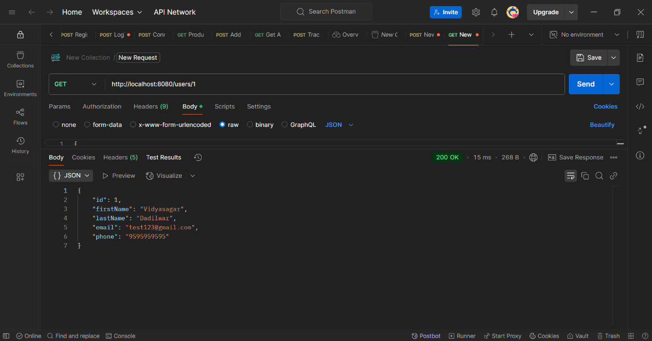  
**Creating a user**  
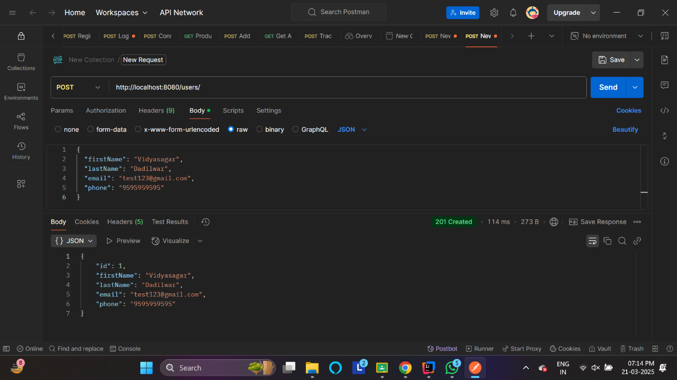

**Flight Service Endpoints**  
  
**Getting flights**  
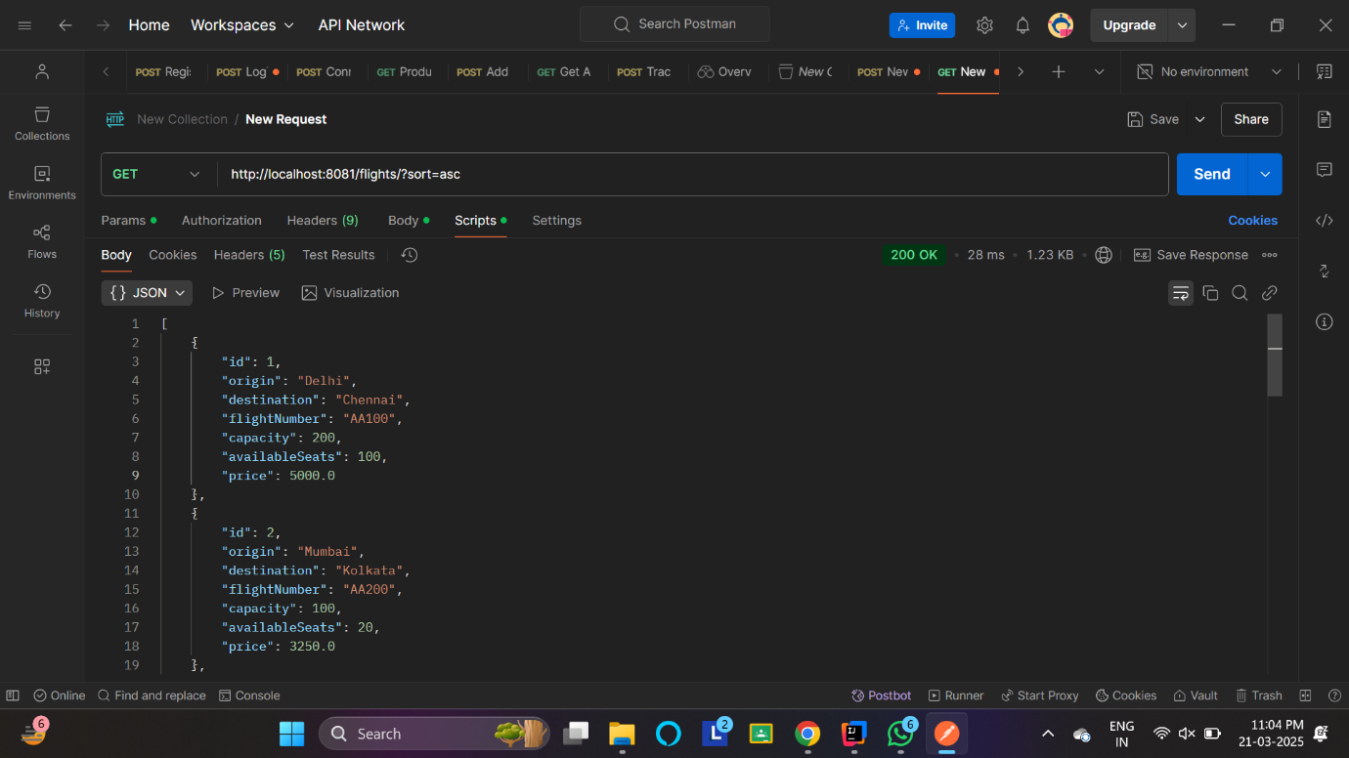

**Getting individual flight**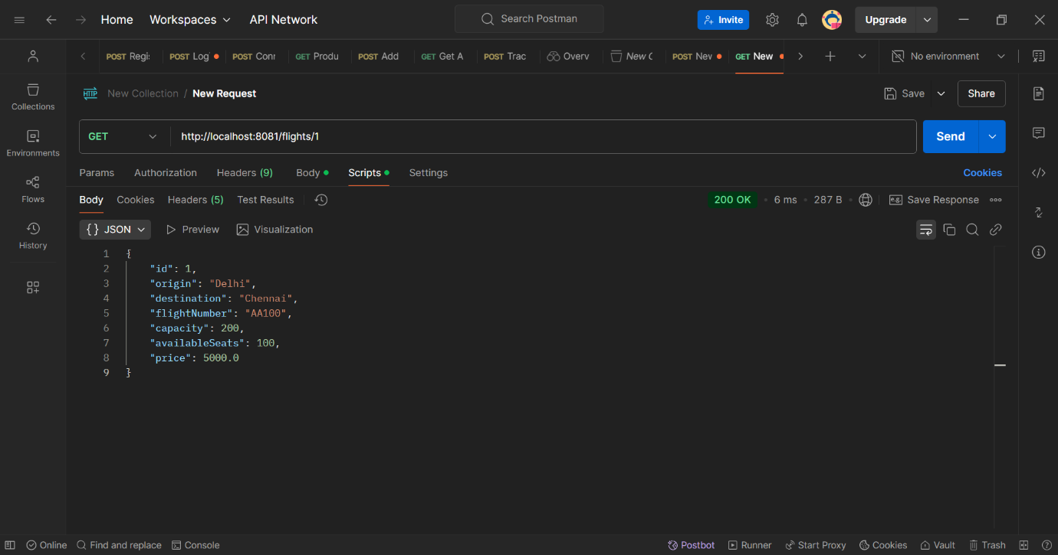

**Creating a flight**  
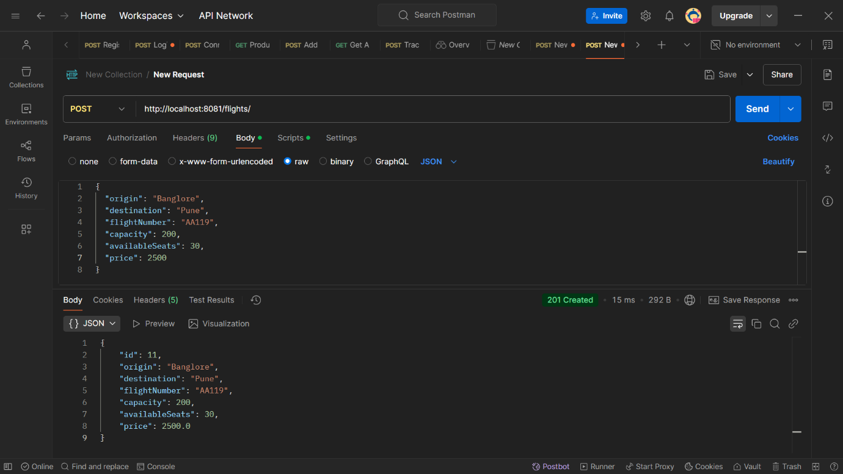  
**Getting a flight schedule**  
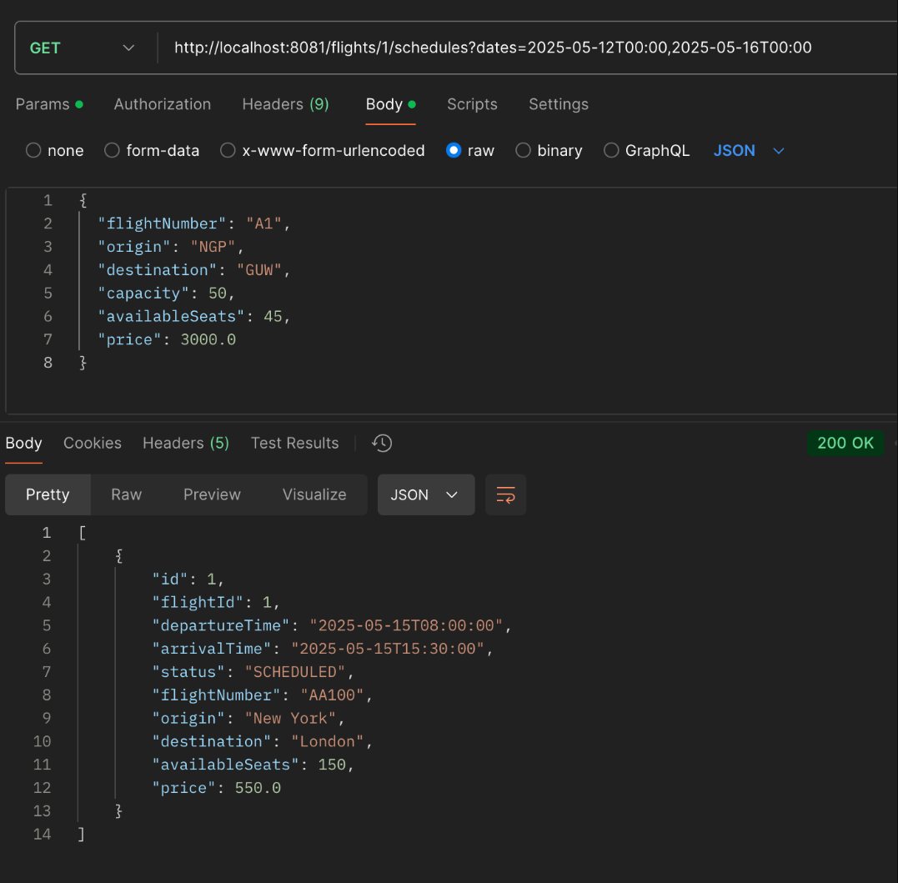

**Ticket Service Endpoints**  
  
**Booking a ticket**  
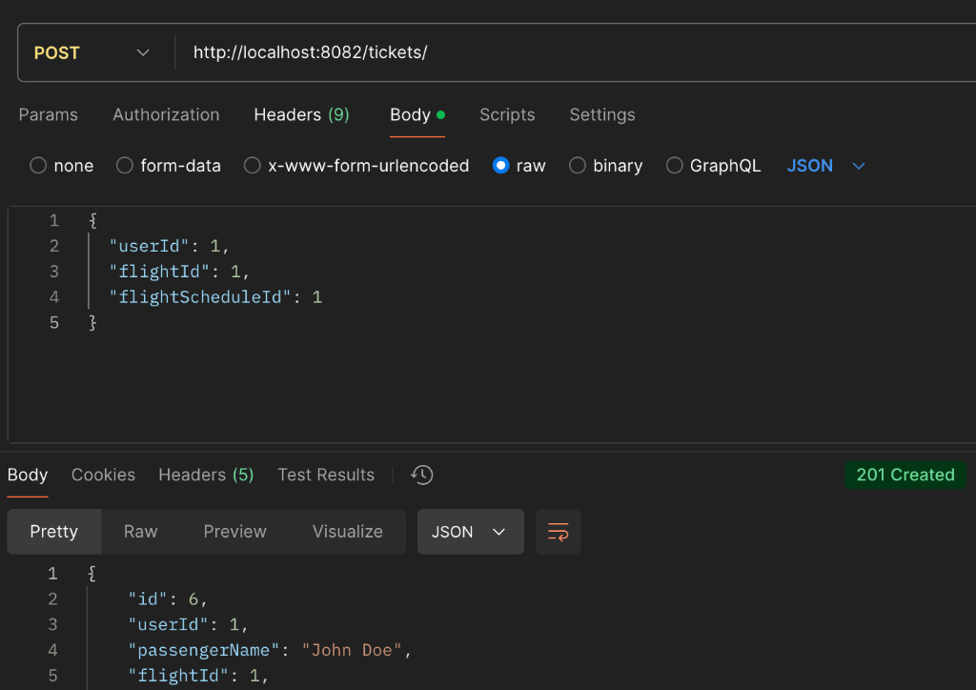  
  
**Getting a ticket**  
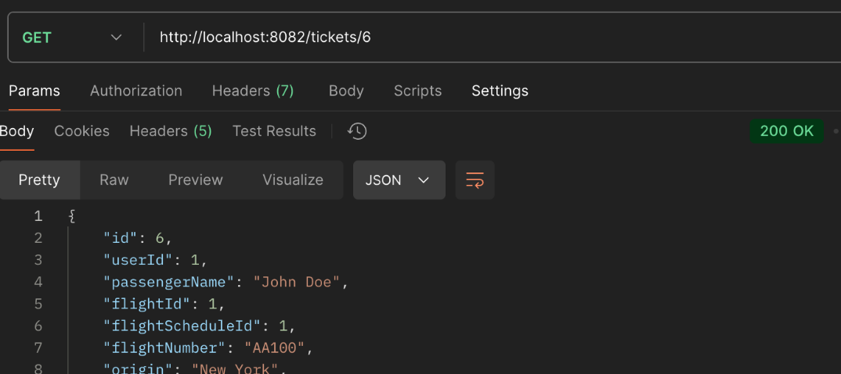  
  
**Deleting a ticket**  
